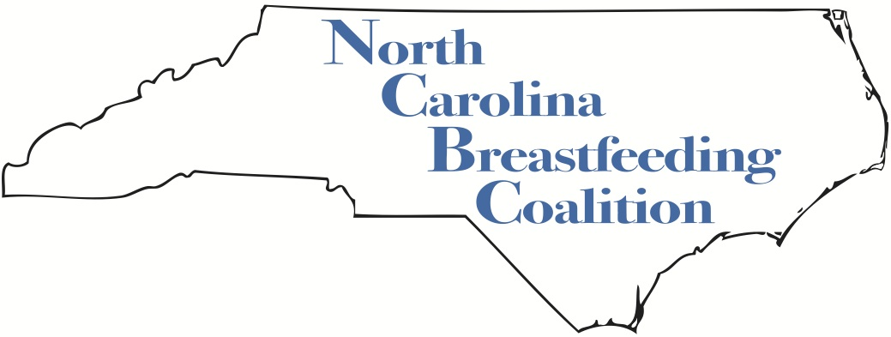

NCBC is a 501(c)(3) non-profit organization bringing together health care providers, agencies, organizations, individuals, families, and all other breastfeeding advocates to support, protect and promote breastfeeding in the state of North Carolina.

NCBC Mini-Grant Team
at c/o April Fogleman
Schaub Hall, Campus Box 7624,
400 Dan Allen Drive, Raleigh, NC 27695

December 6, 2016

Dear Friend of Breastfeeding,

The North Carolina Breastfeeding Coalition is offering mini-grants to organizations trying to protect, promote and support breastfeeding among underserved populations in our state. We will select up to two grantees, and divide $500 total among them. The smallest mini-grant will be $250.

Please review the 2017 NCBC Mini-Grant Application and the guidelines to learn more. Your application must be accompanied by a letter of recommendation from someone not affiliated with your group. Grant requests must be postmarked or emailed no later than January 15, 2017. Incomplete applications, or applications that do not address the guidelines, will not be considered. If you have questions, please contact April Fogleman at 919.208.5700.

Warmly,

Kathy Parry, Chair
on behalf of the NCBC

2017 North Carolina Breastfeeding Coalition Mini-Grant Guidelines

Complete applications must be submitted by January 15, 2017. Please mail to: NCBC Mini-Grant Team at c/o April Fogleman, Schaub Hall, Campus Box 7624, 400 Dan Allen Drive, Raleigh, NC 27695; or email to: adpierce@ncsu.edu. Email submission is preferred.

The aim of the NCBC Mini-Grant program is to increase breastfeeding promotion, protection and support in under-served populations of North Carolina. To that end, the grant application review committee will judge and award based on the following questions:

How will the project:
- Protect, promote and support breastfeeding in under-served populations in NC?
- Advance the mission of NCBC?
- Demonstrate measurable results?
- Have a ripple effect (those who are affected will affect others)?
- Build bridges within the community, particularly with health care professionals and others who support mothers and children?
- Create a sustainable source of support or impact?
- Engage members of NCBC to lend their time, talents and skills / build collaborative opportunities?

Does the application include:
- A carefully prepared, detailed and realistic budget?
- Creative / innovative ideas?
- A letter of support from another breastfeeding advocate who is not part of your organization?
Funds will not be provided for:
- Seed money for fundraisers
- Books for healthcare professionals (We recommend that you provide reference lists instead.)
- Items you can get for free elsewhere
- Advertising in a newspaper
- Postage to mail things to healthcare professionals (We suggest you deliver materials personally.)
- Exhibit fees
- Operational equipment (e.g., cell phones, audio-visual, etc.)
- Ongoing contracts (e.g., cell phone plans)
- Hot/warm lines that will have continuing costs beyond the grant
- Travel outside of NC

Reporting:
- Each grant recipient will correspond with the NCBC Grants Team on a mutually-agreeable timeline determined at time of funding.
- Final project reports are due July 1, 2017. If the project is not complete by that date, a progress report will be due and a final report no later than December 1, 2017.
- A member of the project team will be expected to present a report of activities and results at a NCBC meeting within 16 months of funding.

Additional information:
- Checks are expected to be deposited within 30 days of being dispersed by NCBC.
- If there are remaining funds at the conclusion of the project, the balance must be returned to NCBC. If you would like to use the balance for a purpose related to the original grant application, you must consult with the NCBC Grants Team first.
NCBC 2014 MINI-GRANT APPLICATION
(Postmarked or Email due date NO LATER THAN January 15, 2017)

NAME: |  |  | NAME OF ORGANIZATION:
ADDRESS:

CITY:

STATE: | ZIP: | PHONE:
E-MAIL:

$ AMOUNT REQUESTED: $

PROPOSED PROJECT START DATE:

Names of Board of Directors / Project Leaders:

Not for Profit Status:

DESCRIPTION OF WHAT THE GRANT MONEY WILL BE USED FOR: (Please consider the judgment criteria described in the guidelines.)

PLEASE INCLUDE:

1. A budget showing how you plan to spend the money.

2. Your group’s most current annual financial report.

3. A letter of recommendation from a breastfeeding advocate outside of your organization.

I agree to ongoing communication with the NCBC Grants Team and to submitting a progress and/or final report of how we used this money by no later than ten weeks after receiving any funds.

Print Name: Signature:

